**Tokyo Olympic 2020**

After recent celebration of Tokyo Olympic 2020, you are tasked to create a simple mobile application for Tokyo Olympic information system. For this mobile application, you are provided with API to access instead of real database. Please run the given local API Server file and check it for further documentation. Use **PC_[PARTICIPANT ID]** as your android project name. Below are the requirements for each menu.

1. **Home Activity**

In this activity, shows Tokyo Olympic 2020 Logo. There are two buttons that redirect to **Countries** and **Sports** Activity.

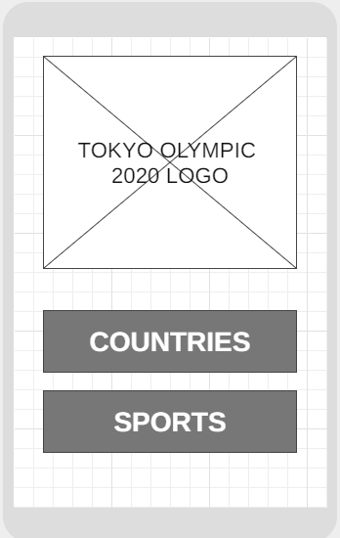

Figure . Home Activity

1. **Countries Activity**

This activity shows list of all participating countries in the Olympic. There will be a flag image of the corresponding country beside each country name. Provide search feature in this activity.

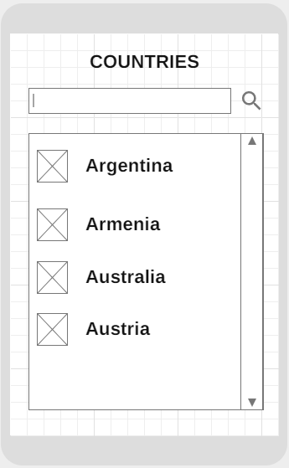

Figure . Countries Activity

1. **Sports Activity**

This activity shows several sports that are contested in this Olympic. Shows the Olympic logo beside its name. There is a time icon beside the sports name that can be used to show the schedule.

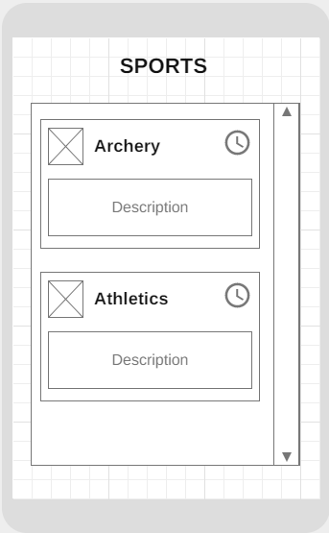

Figure . Sports Activity

1. **Sport Schedule**

This is a pop-up window that will be shown when clicking time icon beside the sports name in the Sports Activity. This pop-up will show all corresponding schedule for that sports type.

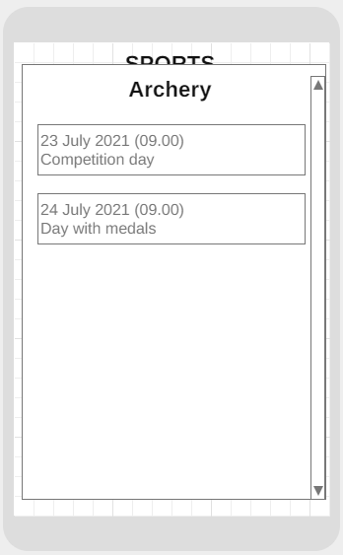

Figure . Sports Schedule Pop-up